**Pasos Instalación ReactJS**

Step 1. Install Homebrew :

Homebrew is a type of platform dependency installation software which would allow us to install all

the download and install all the required files. To install Homebrew open you terminal prompt and type the below command :

/usr/bin/ruby -e "$(curl -fsSL https://raw.githubusercontent.com/Homebrew/install/master/install)"

Step 2. Install Node.js :

Next step is to install the node.js online using command.

brew install node

Step 3. Install watchman :

brew install watchman

Step 4. Install React Native CLI :

npm install -g react-native-cli

Step 5. install Xcode for IOS And Android Studio for Android

Step 6. Create your first react native project in MAC :

react-native init MyProject

Step 7. Run your created project

cd MyProject

react-native run-ios

react-native run-android

//For IOS

**Solución**

**How to Fix xcrun: error: unable to find utility "instruments", not a developer tool or in PATH**

I just got a new machine and downloaded XCode. I used git to clone my ReactNative project from Github. I have everything ready to go. But when I run react-native run-ios I see

xcrun: error: unable to find utility "instruments", **not** a developer tool **or** **in** PATH

The fix for this is pretty simple but of course not intuitive.

You need to launch XCode and agree to the terms first. Then go to Preferences > Locationsand you'll see a select tag for Command Line Tools. Click this select box and choose the version of XCode you'll be using.

After this you can go back to the command line and run react-native run-ios

Here is a screen shot

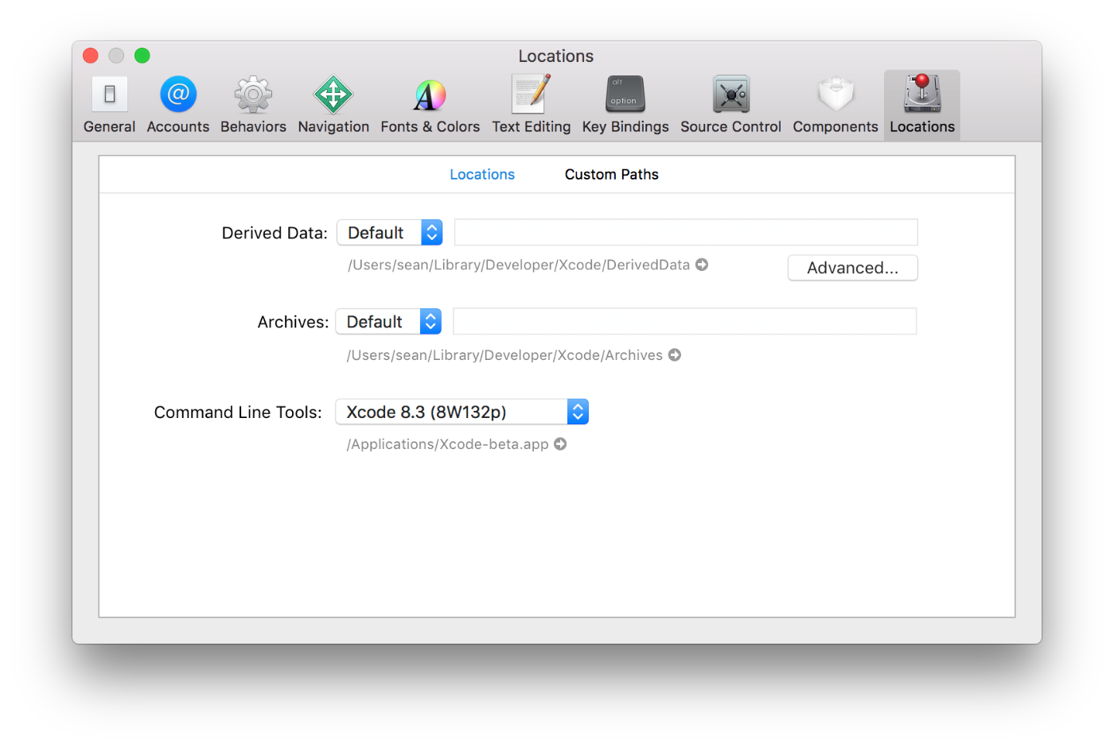

react-native run-ios

Hay veces que cuando no cargan los proyectos hay que limpiar la cache

rm -rf ios/build

//For Android

**Solución**

### 1. Install Android Studio

Firstly, let’s refer to the [React Native installation guide, for Android](https://facebook.github.io/react-native/docs/getting-started.html#android-development-environment). We’ll download Android Studio (about 450MB).

Drag Android Studio into your Applications folder and then Open Android Studio. You’ll be presented with a Setup Wizard — let’s run through that:

Tick both ‘Performance’ and ‘Android Virtual Device’ to get an optimised Android Virtual Device for testing. This has got a bit to download, the Android SDK and Virtual Device are quite big…go get a coffee or something

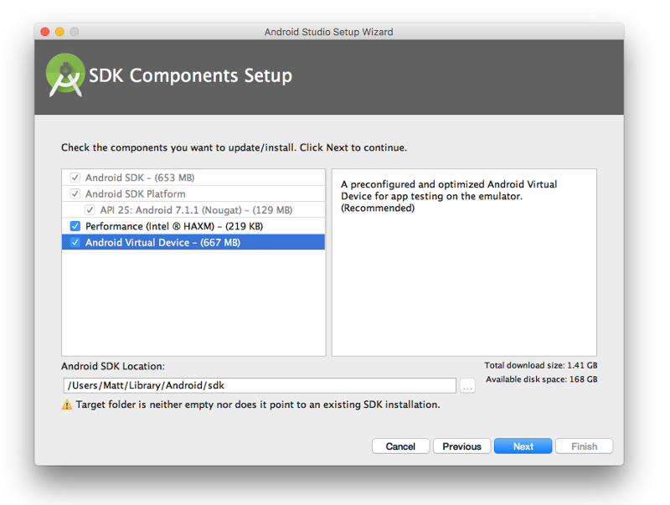

### 2. Setup Paths

While that’s downloading, let’s setup paths to the Android SDK (so that the RN CLI knows where it is):

Open terminal and create/edit your .bash_profile file:

nano ~/.bash_profile

This will open a file called .bash_profile in terminal. Next, paste the following to the bottom of the file:

# Android SDK  
export ANDROID_HOME=~/Library/Android/sdk  
export PATH=${PATH}:${ANDROID_HOME}/tools:${ANDROID_HOME}/platform-tools

Then save and close the file (CMD + x, yes, enter).

### 3. Install JDK for Mac OSX

The Android CLI requires the Java Developer Kit (JDK) — simply download and install it:

### 4. Install the extras

There’s a few extra things that we need to install to get us up and running. Bear with me…

#### 4.1 Google Play Services

Install Google Play Services (for things like Google Analytics, Google Login etc).

* Open Android Studio > Configure > SDK Manager
* Go to the middle ‘**SDK Tools**’ > Click ‘**Show Package Details**’ (bottom right)
* Click ‘**Google Play Services**’, then hit apply and follow the instructions to download/install it

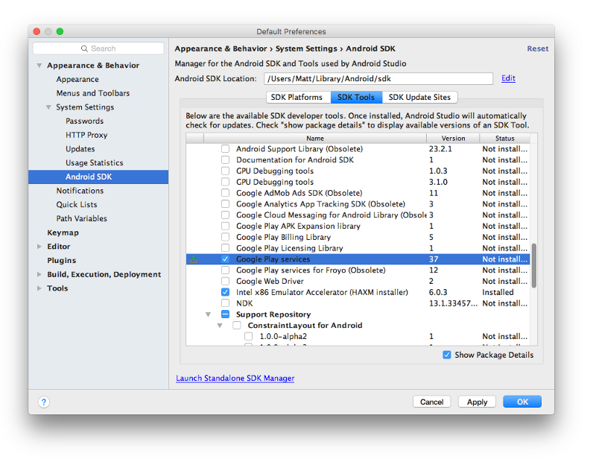

#### 4.2 Android System Images

In order to create new emulators, we need to install a few system images.

* Run android sdk from terminal
* Check the 3 system images selected below (Android TV Intel x86 Atom System Image, Google APIs Intel x86 Atom 64 System Image, Google APIs Intel x86 Atom System Image)
* Hit Install 3 Packages and follow the prompts to install

### 4.3 Android 6.0

By default you’ll get the latest and greatest SDKs installed. But React Native and most of their plugins use the Android 6.0 SDK build tools. So you’ll need to install that to run/build your app.

* Open Android Studio > Configure > SDK Manager
* Click on the blue link ‘Launch Standalone SDK Manager’ (bottom left)
* Check the 2 system images selected below (Android 6.0 SDK Platform and Android 6.0 Google APIs Intel x86 Atom System Image)
* Hit Install 2 Packages and follow the prompts to instal

### https://cdn-images-1.medium.com/max/800/1*-eSCt2xhhr3zkItDwzv3ZA.png 5. Running a React Native App in the Android Simulator

Now is a good time to do a quick restart of the machine, before moving on. Then, from terminal, run:

android avd

This will open the Android Virtual Device Manager. If you don’t have any devices setup, create one with similar settings to below:

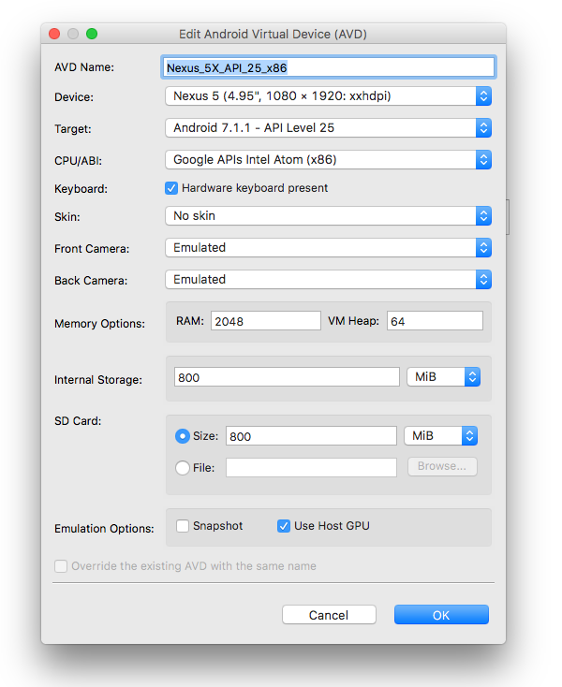

Click ok, then select the device to open, and click Start.

Wait for that device to fire up (keep that terminal window open). Then, in a new terminal window, enter the root directory of your React Native project, then run:

react-native run-android

Things change all the time, let me know in the comments if something doesn’t quite work and I’ll look into updating this.